Experiment 4: Create a Scrum Project in Jira
AIM: To create a Scrum project in Jira, add and prioritize backlog items, create a one-week sprint, and start the sprint.
PROCEDURE:
- Create a Scrum project in Jira.
- Add at least five user stories or tasks to the backlog.
- Prioritize the backlog items based on importance.
- Create a one-week sprint and move the selected items into it.
- Start the sprint and capture the sprint board screenshot.
- At the end of the sprint, capture the completed sprint board screenshot.
OUTPUT:
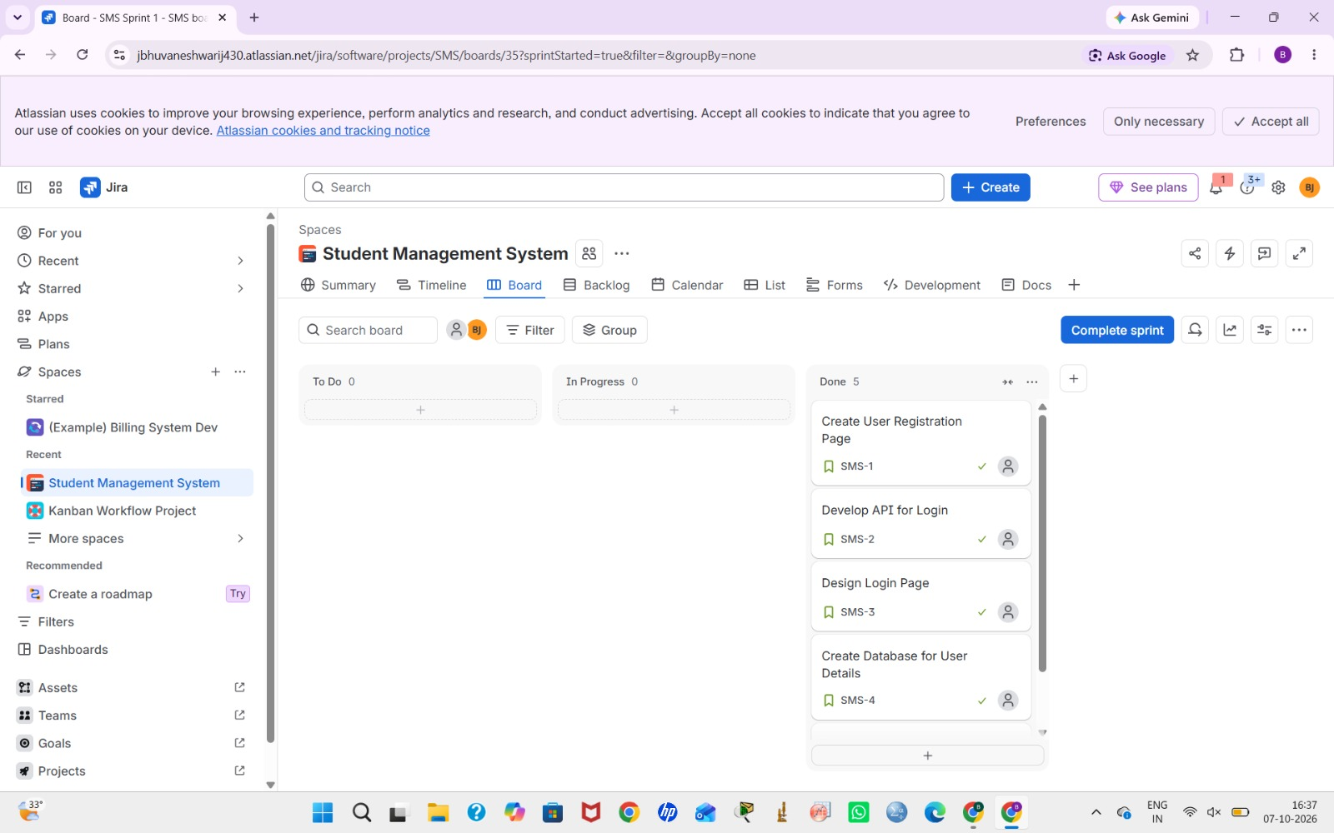

RESULT: A Scrum project was created successfully in Jira, and the backlog, sprint planning, and sprint board were demonstrated.

